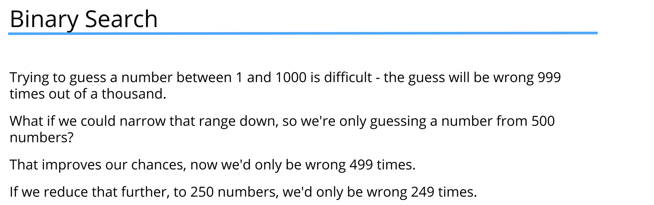

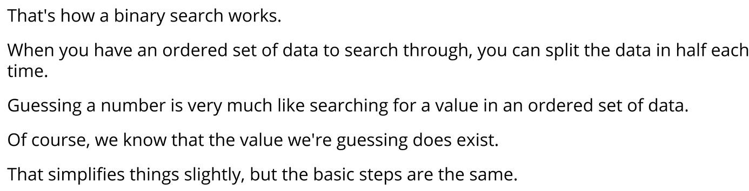

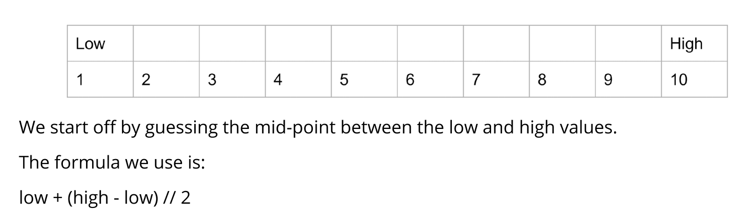
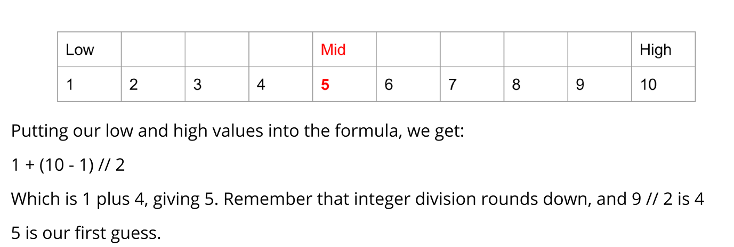
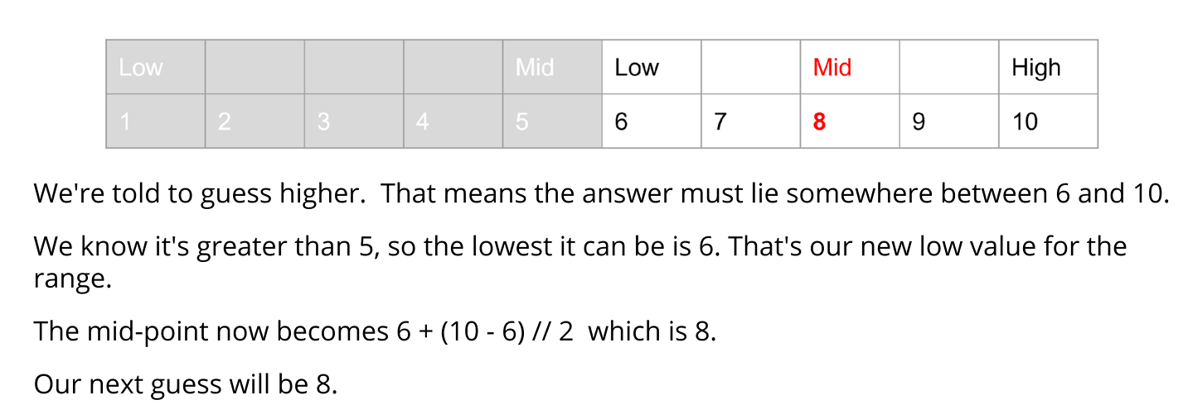
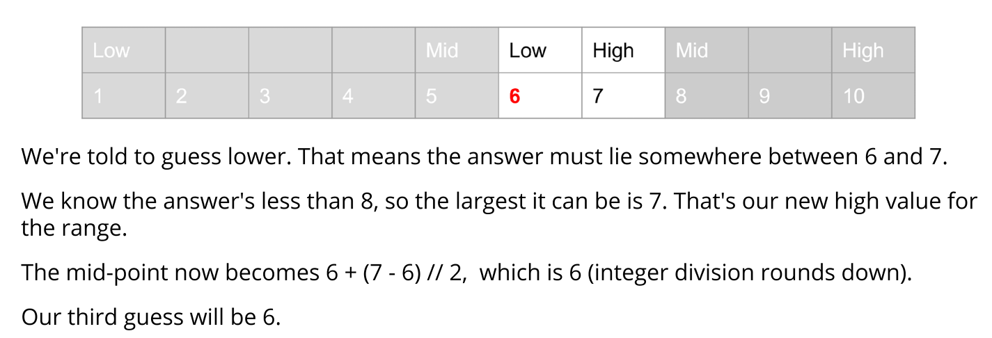
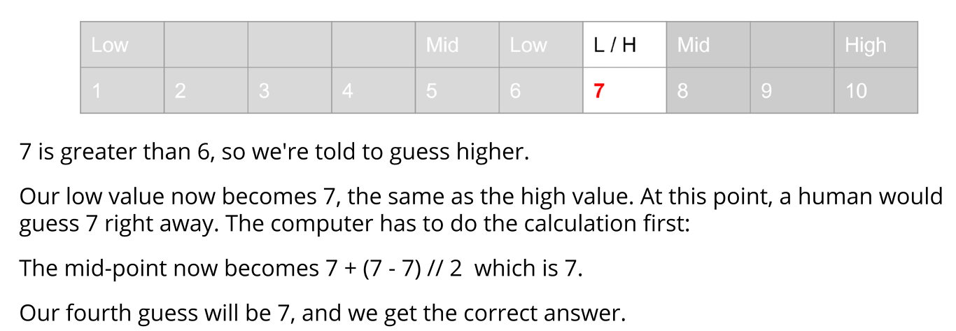
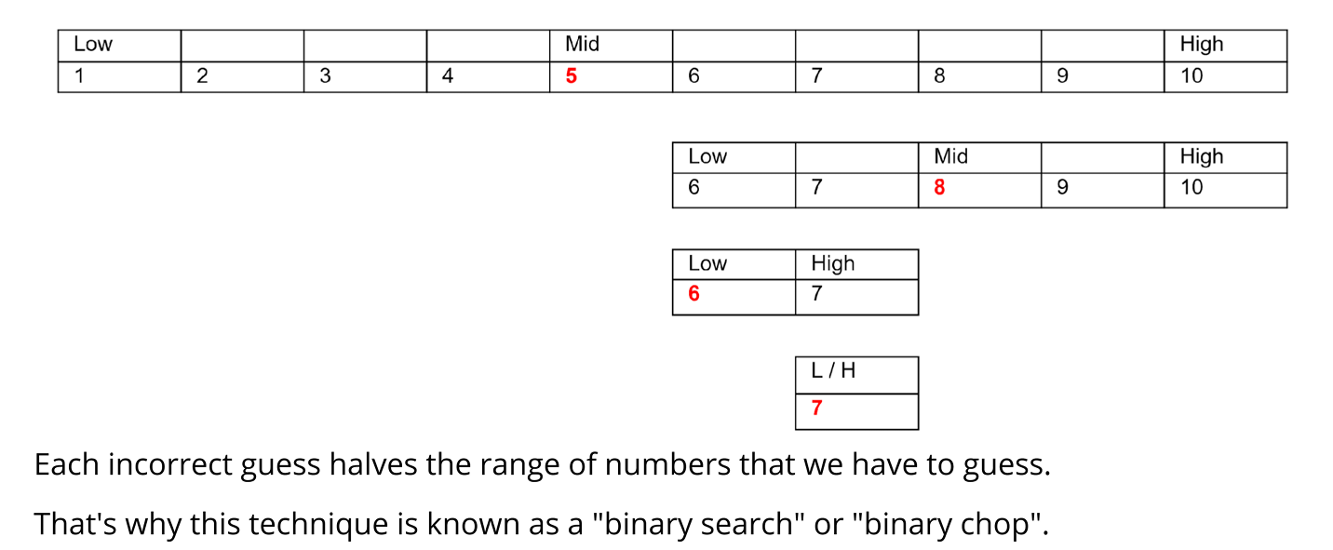
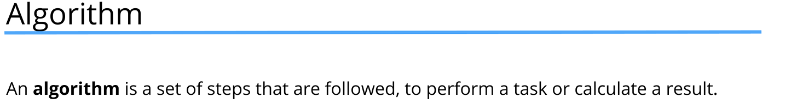
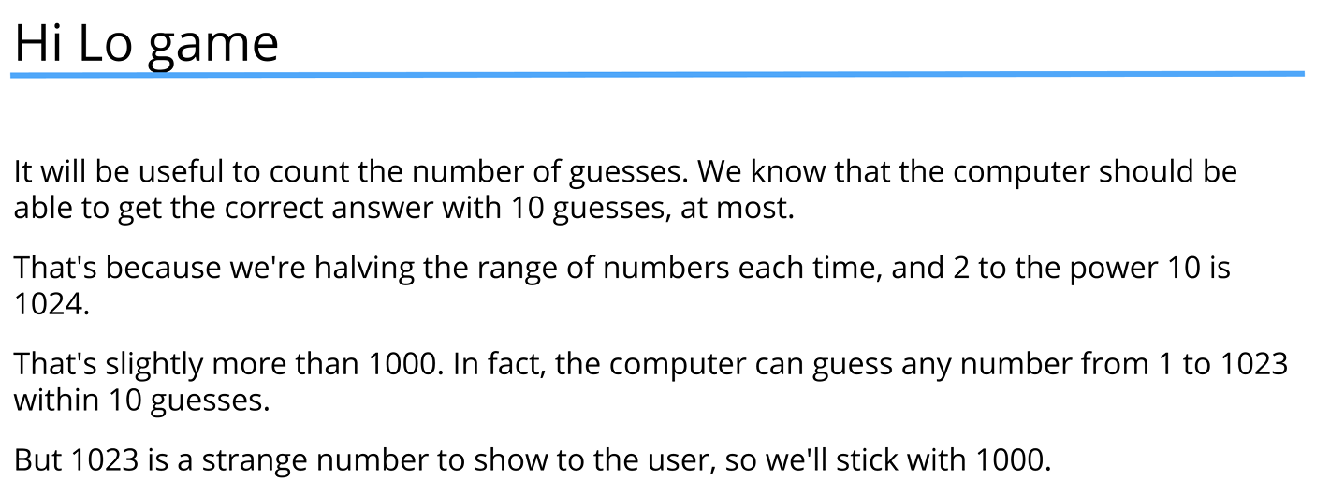
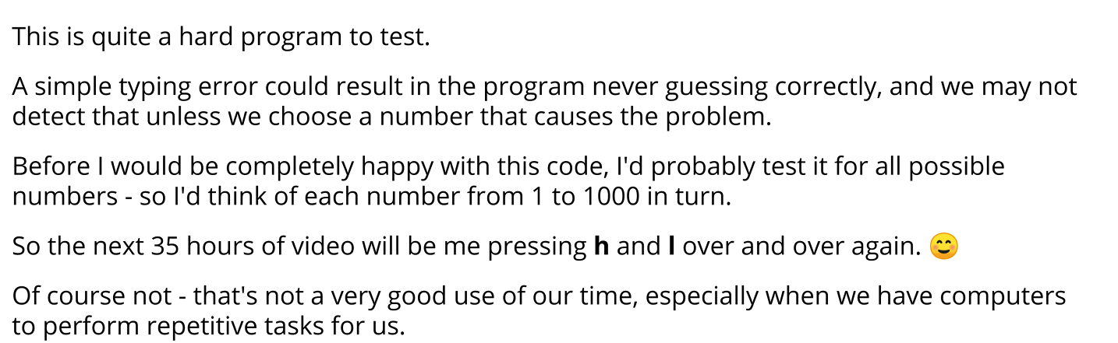
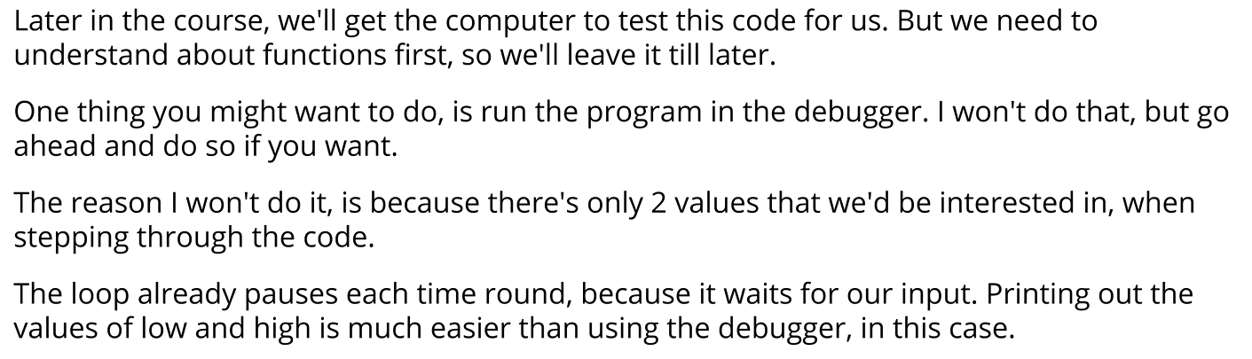
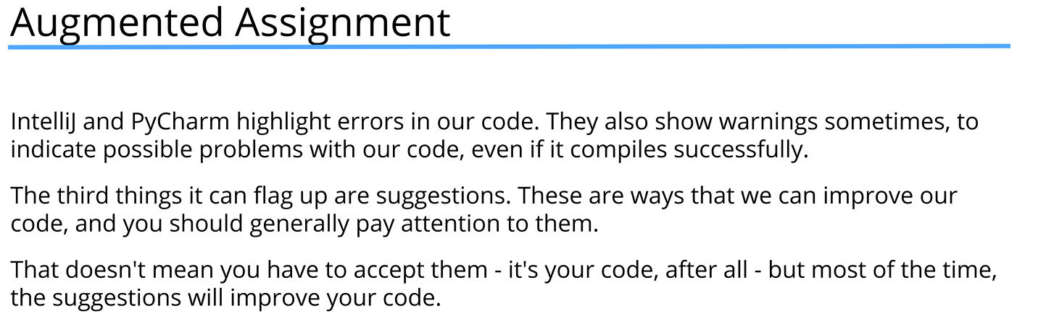
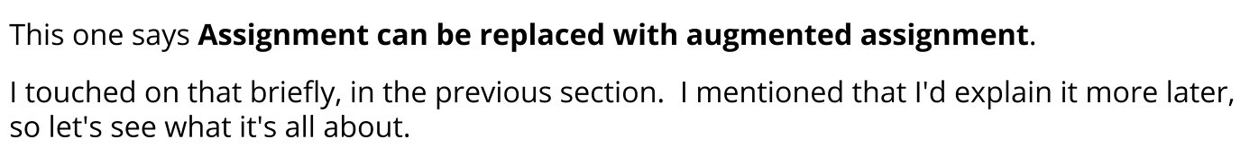
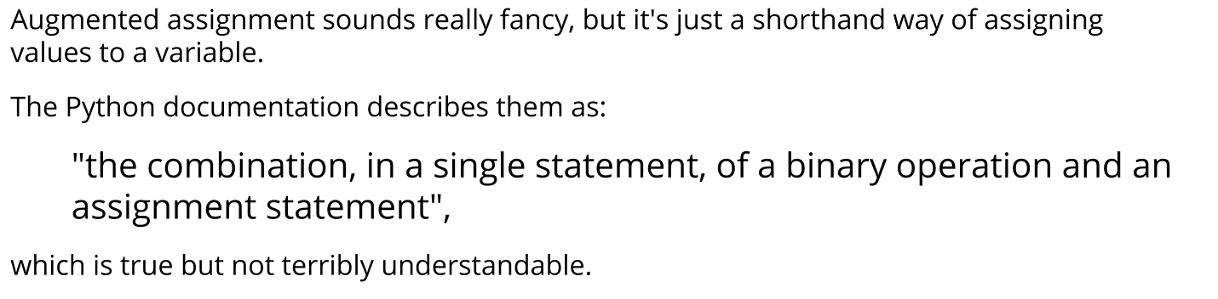
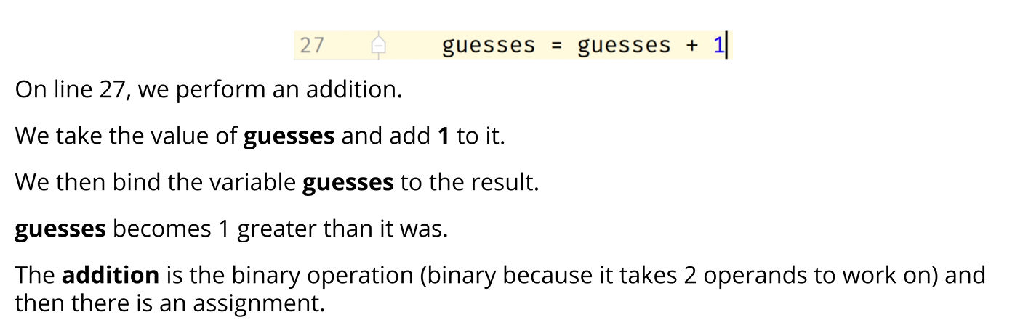
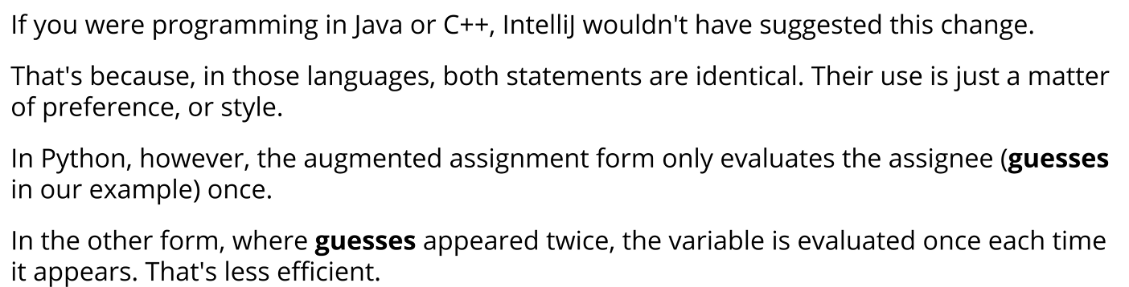
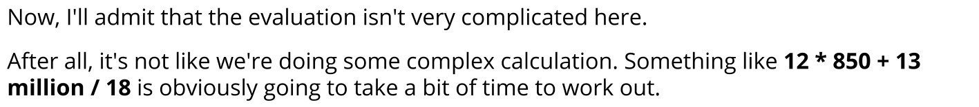
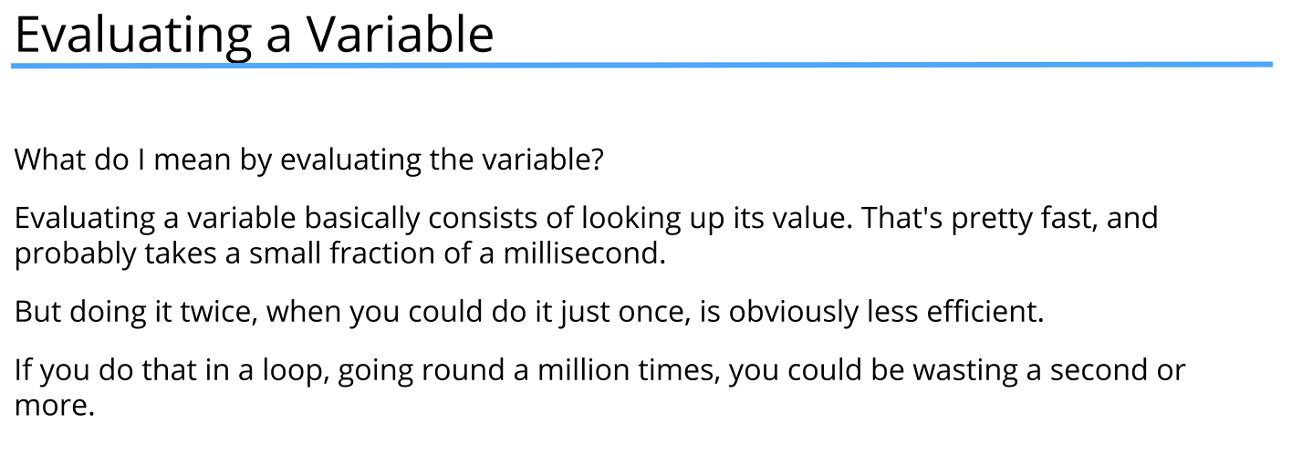
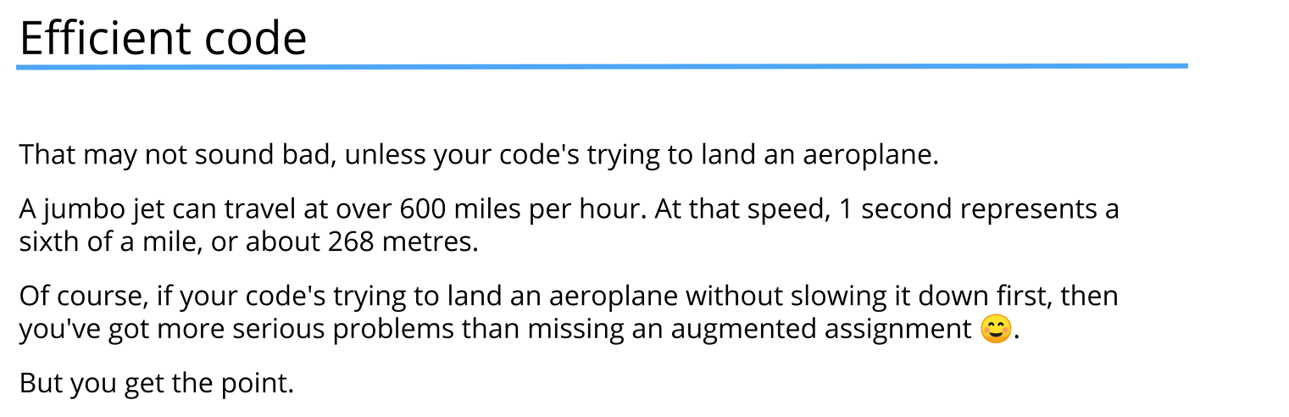
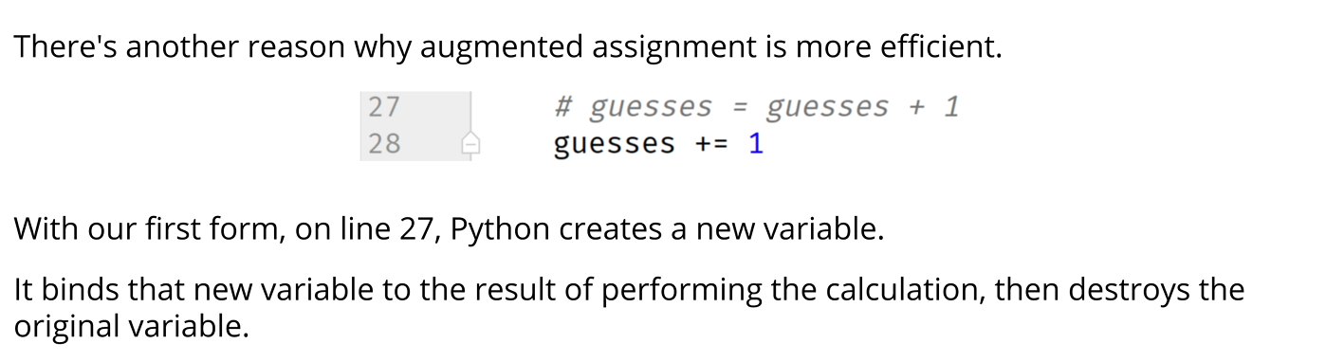
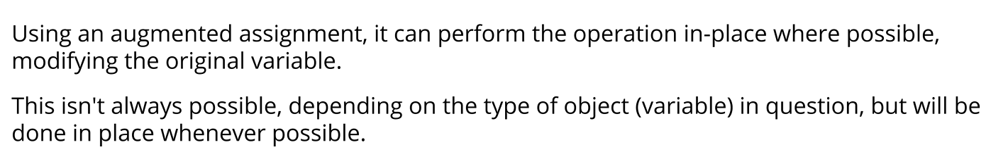

Hilo game
low = 1
high = 1000

print("Please think of a number between {} and {}".format(low, high))
input("Press 'Enter' to start ")

guesses = 1

while low != high:
print("\tGuessing in the range of {} to {}: ".format(low, high))
guess = low + (high + low) // 2

high_low = input("My guess is {}. Should I guess higher or lower? " \
"Enter h or l, or c if my guess was correct "
.format(guess)).lower()
if high_low == 'h':
#Guess higher. The low end of the range becomes 1 more than the guess
low = guess + 1
elif high_low == 'l':
#Guess lower. The high end of the range becomes 1 less than the guess
high = guess - 1
elif high_low == 'c':
print("I got it in {} guesses!".format(guesses))
break
else:
print("Please enter h, l, or c")
continue
guesses += 1

else:
print("You thought of the number {}".format(low))
print("I got it in {} guesses!".format(guesses))

